# Simulation Exercise for the Exponential Distribution

## Author: Edward Lau

### Overview: I am going to report on a simulation exercise and inferential data analysis. The first part will examine how the exponential distribution behaves under simulation. The second part will analyze the ToothGrowth data in the R dataset package.

### Part 1: Exponential distribution simulation

The following code will do 1000 simulations of random exponential distribution with lambda = 0.2 and 40 observations. It will then get the means and variances of those 1000 simulations.

set.seed(100)  
sim <- 1000  
means = NULL  
vars = NULL  
for (i in 1: sim){  
 means <- c(means, mean(rexp(40,0.2)))  
 vars <- c(vars, var(rexp(40,0.2)))  
 }

The histogram of the simulation result is below:

hist(means)

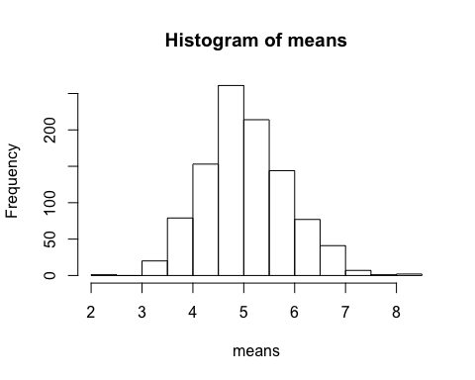

### Question 1: The mean of the simulated values:

mean(means)

## [1] 5.03498

which compares quite well to the theoretical value of 1/0.2 = 5.

### Question 2: The standard deviation of the distribution:

hist(vars^0.5)

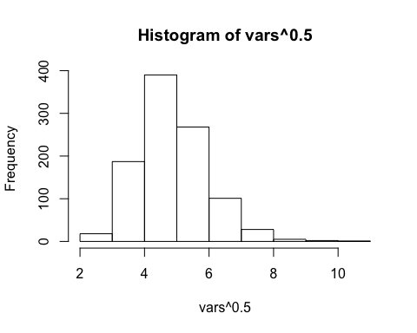

mean(vars^0.5)

## [1] 4.869785

Hence the variance of the simulation is about (1/0.2)^2 ~ 25; and the standard deviation ~5, which compares quite well to the theoretical value of 1/0.2 = 5.

### Question 3: Normal distribution?

quantile(means)

## 0% 25% 50% 75% 100%   
## 2.465068 4.489275 4.955715 5.558254 8.107675

quantile(rnorm(1000,mean=mean(means), sd=sd(means)))

## 0% 25% 50% 75% 100%   
## 2.695655 4.520082 5.023524 5.610620 7.410693

It seems like the quantiles of the two distributions are quite comparable...